**Sri Lanka Institute of Information Technology**



**Data Warehouse and Business Intelligence – Assignment 2 Submission**

Name: Dinoja Nimals

Reg-No: IT20203412

Batch: Year 03 Semester 01

**Contents**

1. Data Source ...…...…………………………………………………….3
2. SSAS Cube Implementation………………………………………......4
3. Demonstration of OLAP operations ………………………………….9
4. Report 1…………………………………………………………9
5. Report 2………………………………………………………...10
6. Report 3………………………………………………………...10
7. Report 4………………………………………………………...11
8. Report 5………………………………………………………...11
9. Report 6………………………………………………………...12
10. SSRS Reports ………………………………………………………....13
    1. Report 1 - Report with a matrix ……………….……………….14
    2. Report 2 - Report with an SSRS drill-down ………………...…15
    3. Report 3 - Report with more than one parameter …………...…16
    4. Report 4 – Report with an SSRS drill-through…………………17

**1.DATA SOURCE**

Data Warehouse implemented in the previous assignment was used as the source to complete Assignment 1. As described in the Assignment I, the selected data set consisted of transactional data. Customer specific details involved in transactions, Items, customers are keen to purchase, customer participation to promotion campaigns are some of the key details included in the data set.

**ER-Diagram**

The below ER- diagram shows the connection between the entities in the data set and the attributes.

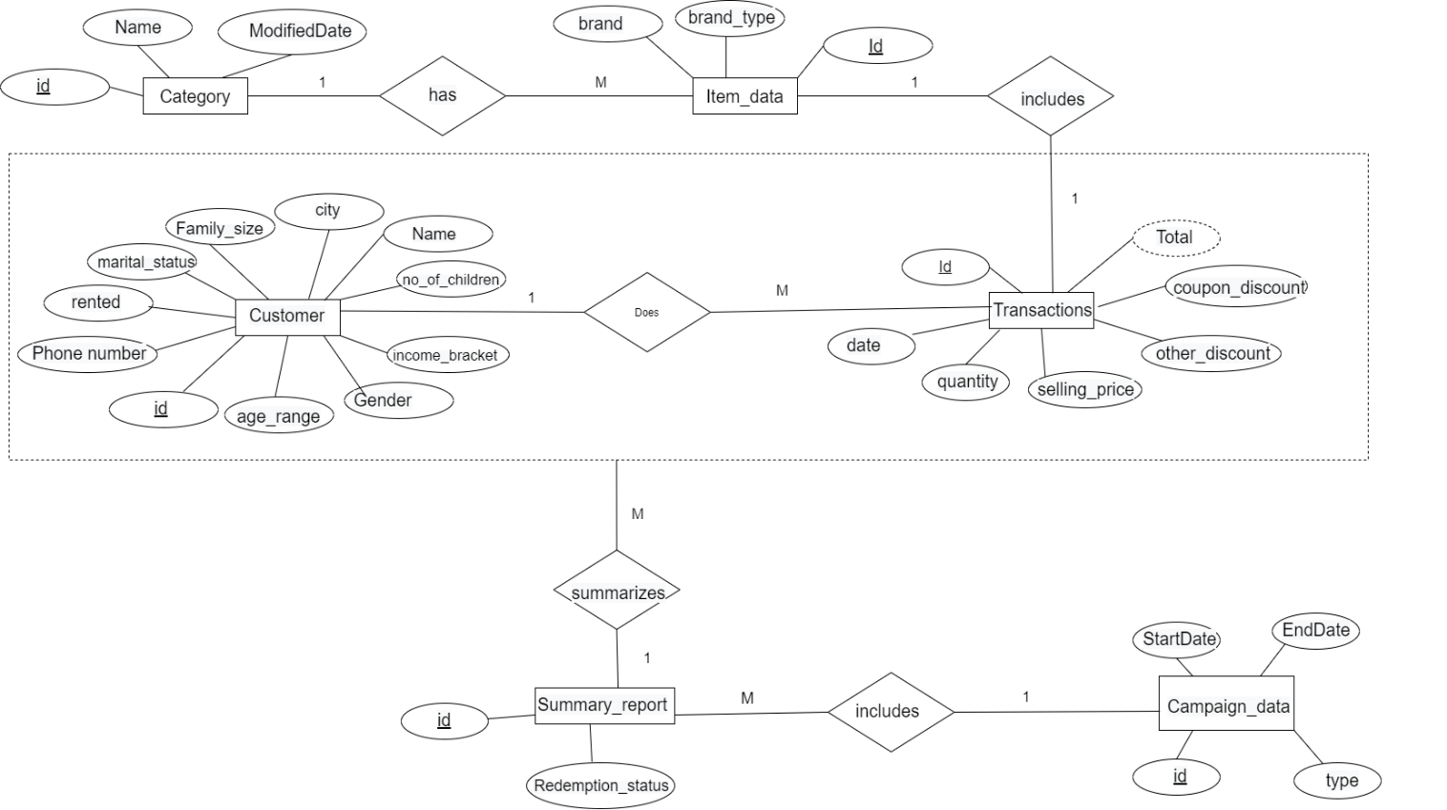

**2. SSAS CUBE IMPLEMENTATION**

1. A new SSAS project was created and named as ‘AmExpert_SSAS’, to begin the SSAS cube implementation. First the created Data warehouse was added as a new Data source and configured

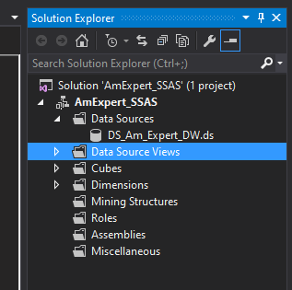

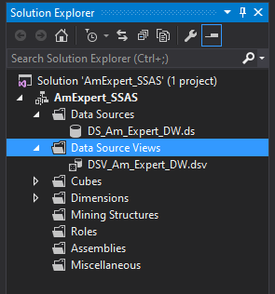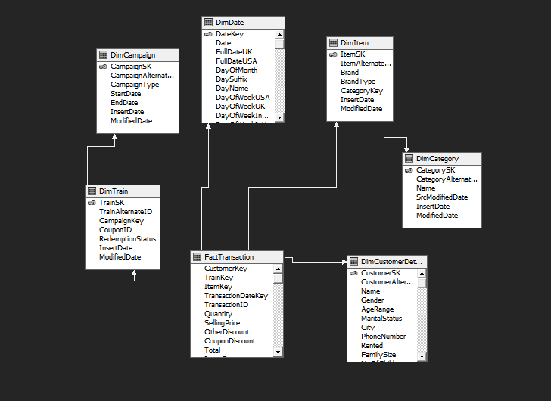

1. Next a new Data Source view was added after adding the same warehouse. In adding the Data source view, first the Fact table was selected and the other tables connected to the fact table was added by clicking on Add Related Tables. The created data source view is attached below.

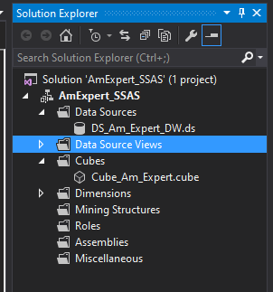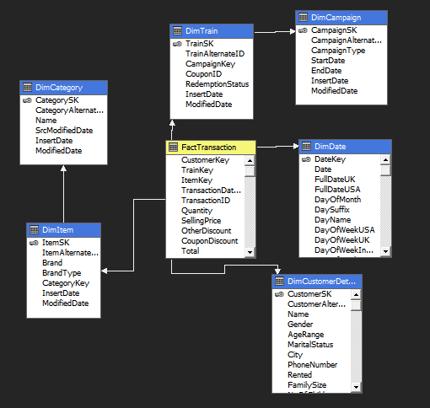

1. Next a cube was created by adding a new cube and selecting the fact table, measures, dimensions appropriately. The created cube is demonstrated below:
2. Next attributes were added to the relevant dimensions.
3. **Train Dimension**

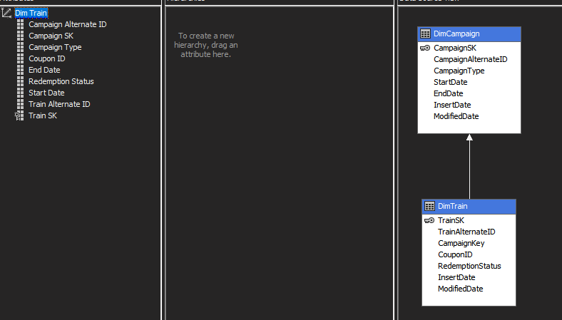

1. **Item Dimension -** Item Dimension, not only the attributes were added but also a hierarchy was created to ease the process of analyzing data. Hierarchy includes item brand type and the brand.

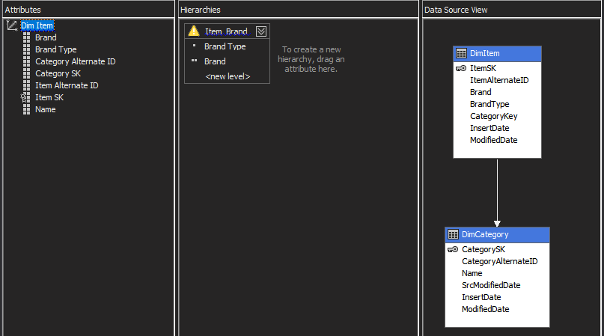

1. **Customer Dimension**

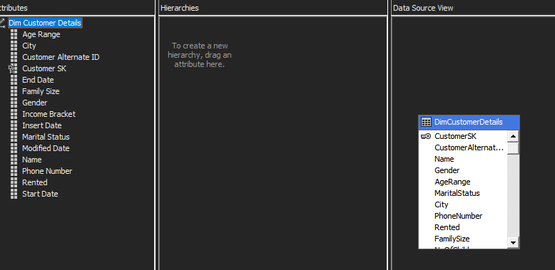

1. **Date Dimension –** Date dimension includes hierarchy with year, month and date attributes.

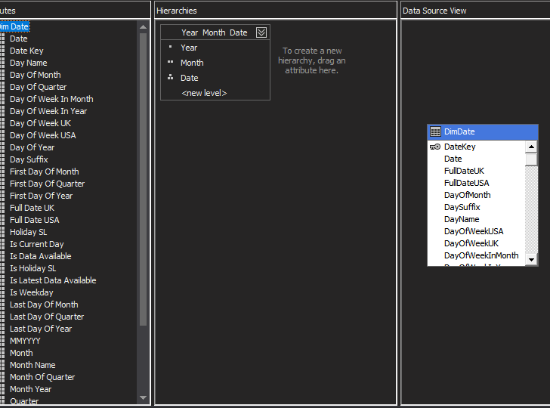

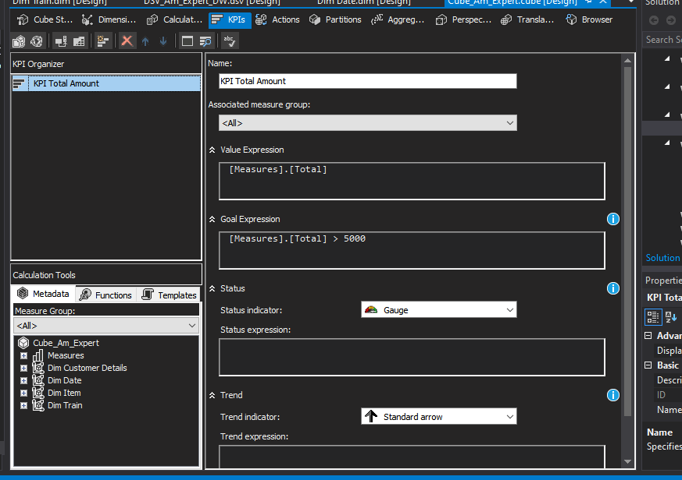

1. As the next step KPIs were created to address business requirements. The below KPIs were created accordingly.

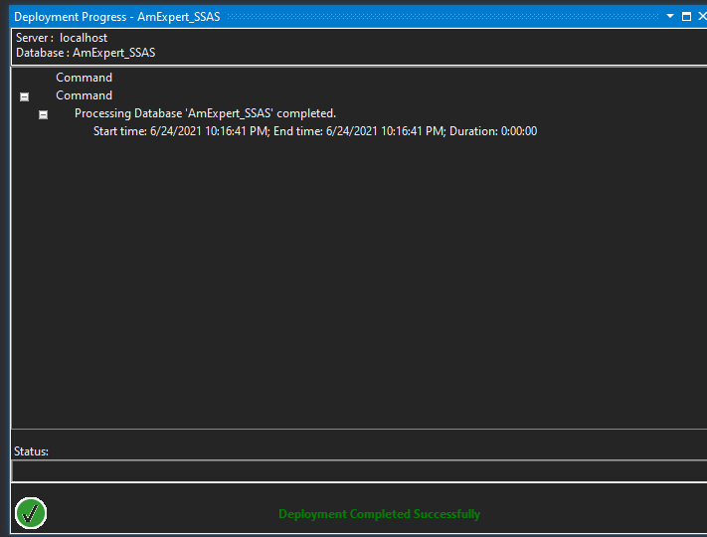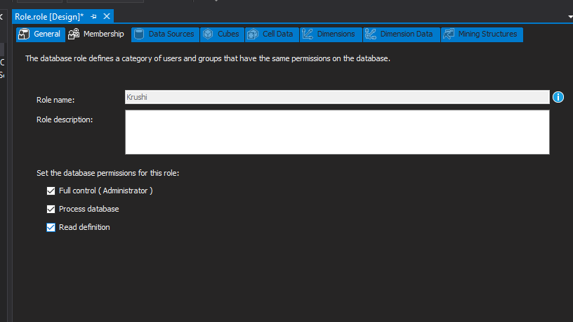

1. As the last step of cube implementation, the cube was deployed.
2. As the next step a role was created by defining permissions assigned to the role. The particular role has full control.

**3. DEMONSTRATION OF OLAP OPERATIONS**

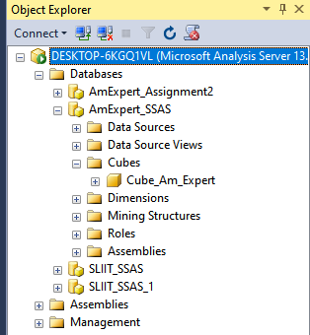

After deployment the created cube is shown in the SQL Server Management Studio.

By dragging and dropping the necessary fields the MDX queries were generated. And extracting the generated MDX queries to Excel power view, reports were created. The created reports using power view are described below:

Report 1

This report analyzes promotion Total amount, customers involved in transactions and quantity of items. This analysis shows the top clients to be motivated, by offering coupons. This analysis is used to identify active customers to the system. Dice as well as power pivot has been used to analyze data.

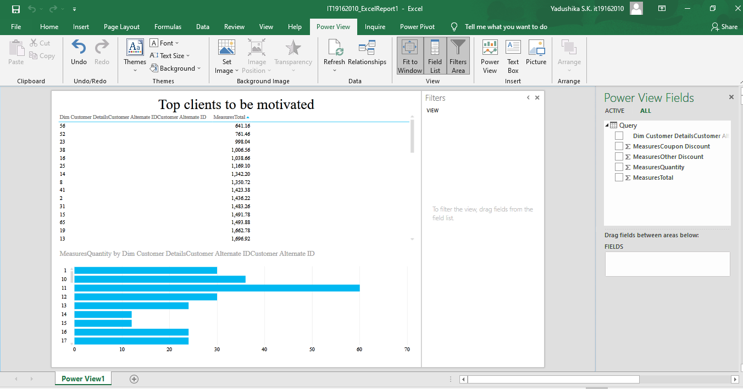

Report 2

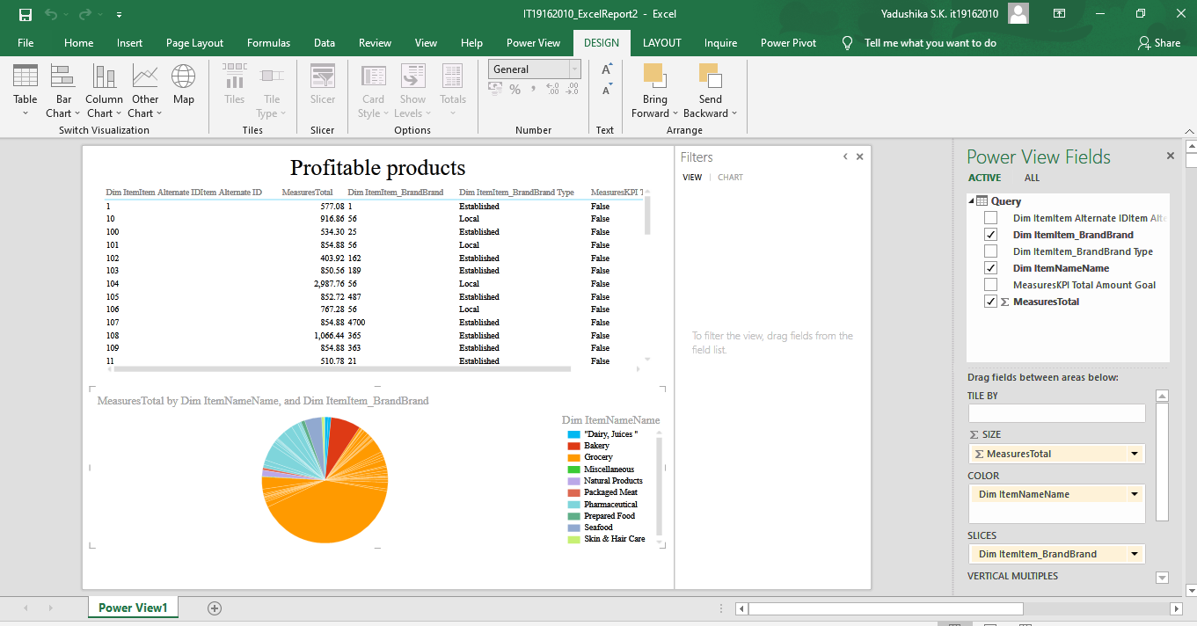This report analyzes data between Item categories, Item brand hierarchy, KPI Goal and Total income. To find out the Categories and Items which makes more profit during the business process. Power pivot and dice have been used.

Report 3

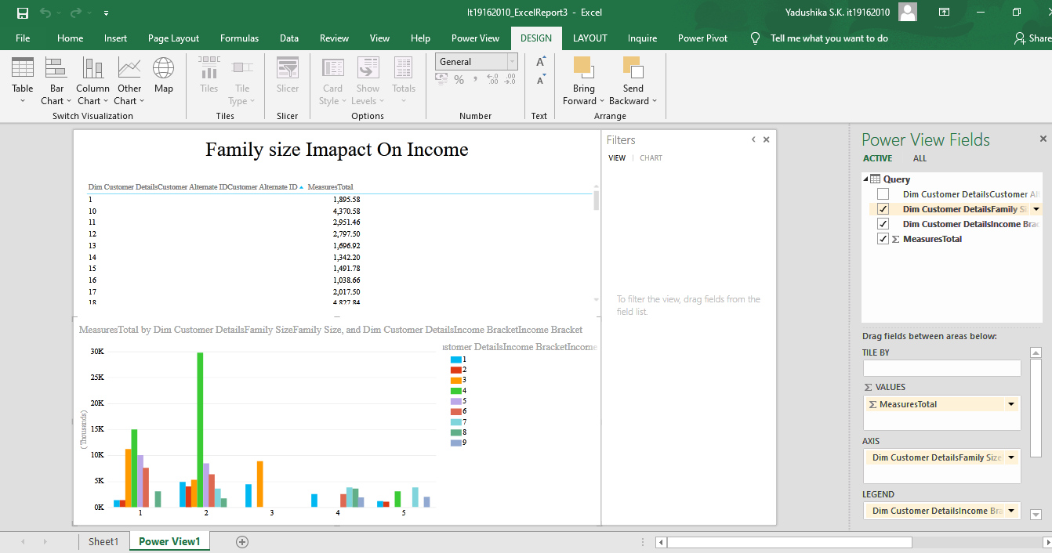This report reflects Total amounts of customers based on family size and income bracket. The income effect relates to how a consumer spends money based on an increase or decrease in his income. So, this report helps us to analyze and decide the coupons to be provided to the customers based on their family size. Helping the user have a better picture about the target client base and methods to approach clients based on the background details. Roll up drill down been used.

Report 4

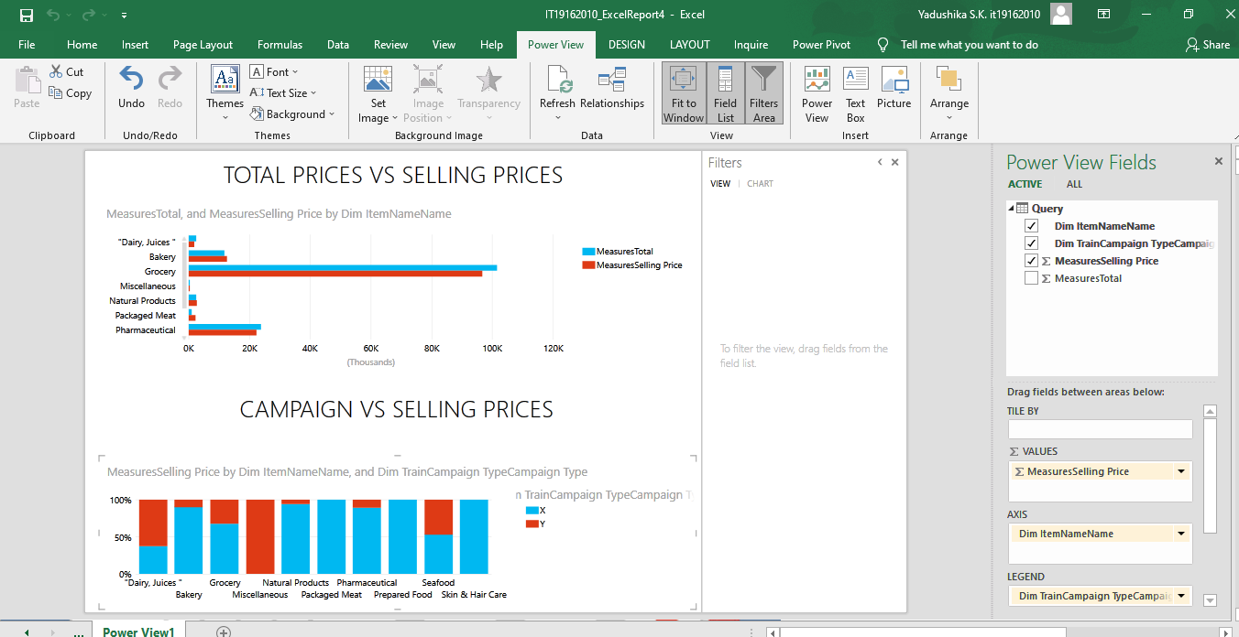This report shows selling prices, total income and campaign types of categories. To analyze the different between the selling price vs total income. And also, to take decision on promoting Items using campaign. Power pivot and roll-up and drill-down have been used.

Report 5

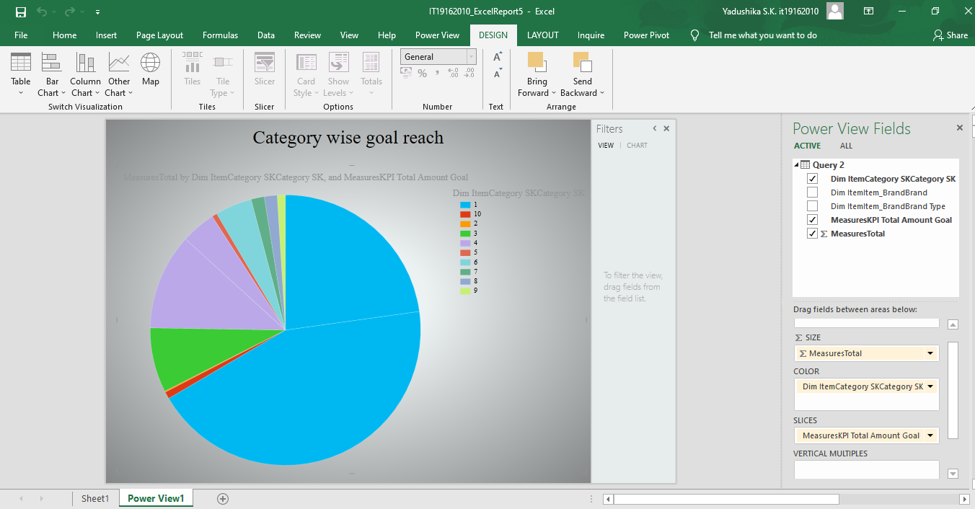This report reflects Total amounts, categories and Total amount goals to analyze and identify the categories which have been reached the goal and the categories which haven’t reach the goal and has low market. Power pivot, slice and dice are been used.

Report 6

This report analyzes data between Cities, coupon discount, other discounts, selling prices and total income. This is to focus on cities which helps to reach the KPI goals. And also, to motivate other countries in order to reach goal and increase the performance of the business. Power pivot is used.

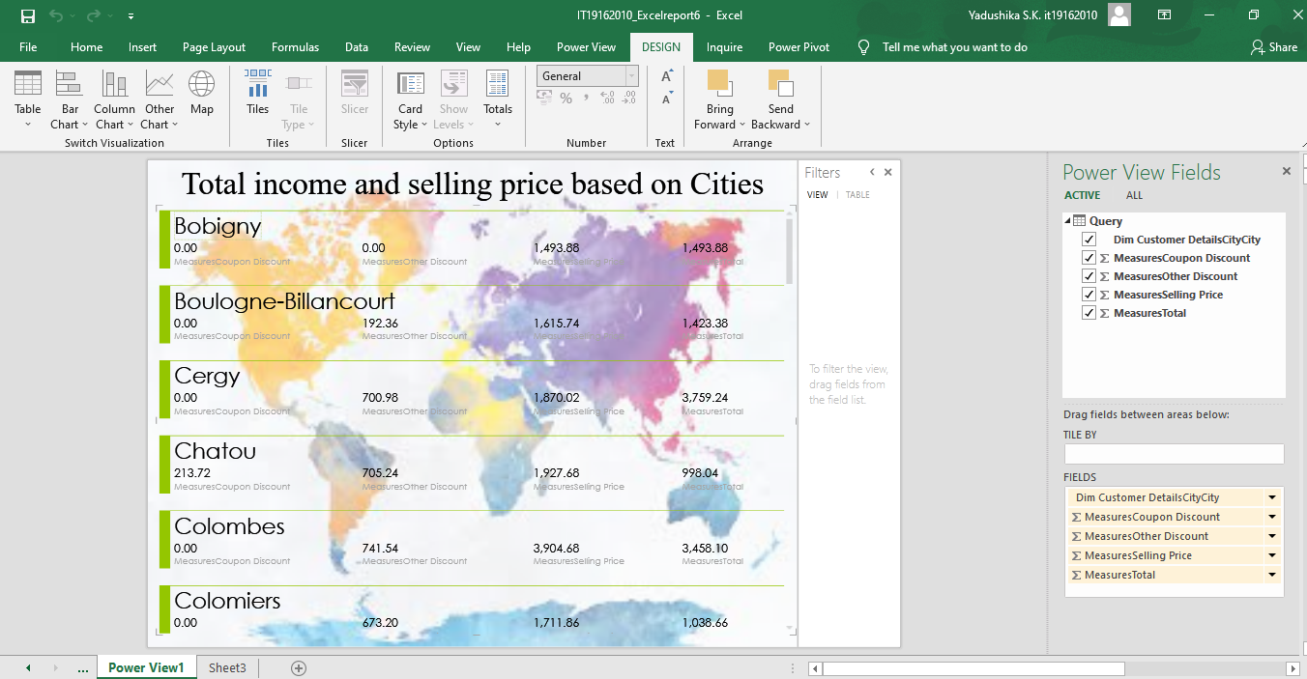

**4.SSRS REPORTS**

Before generating SSRS Reports, SQL Server Services Configuration manager was configured and the web portal was accessed using the URL mentioned below:

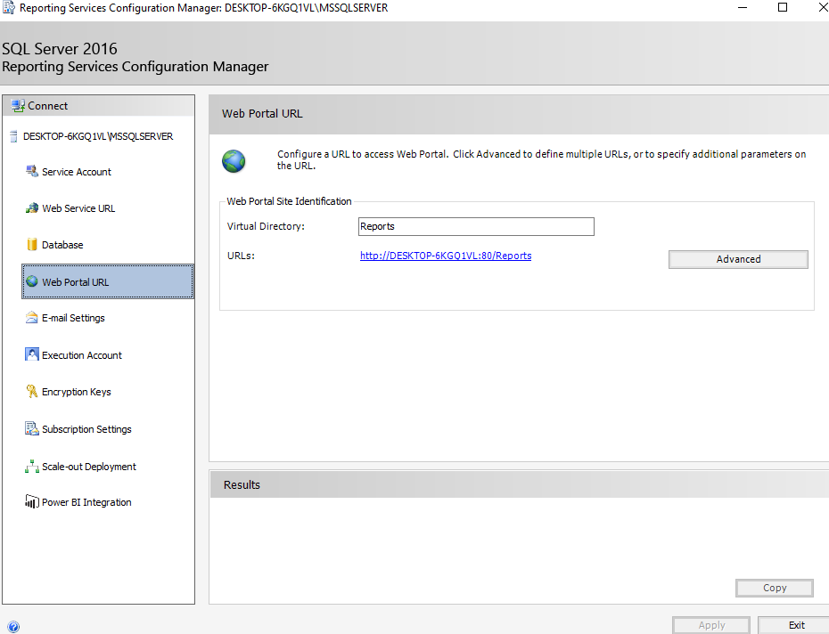<http://desktop-6kgq1vl:80/ReportServer>

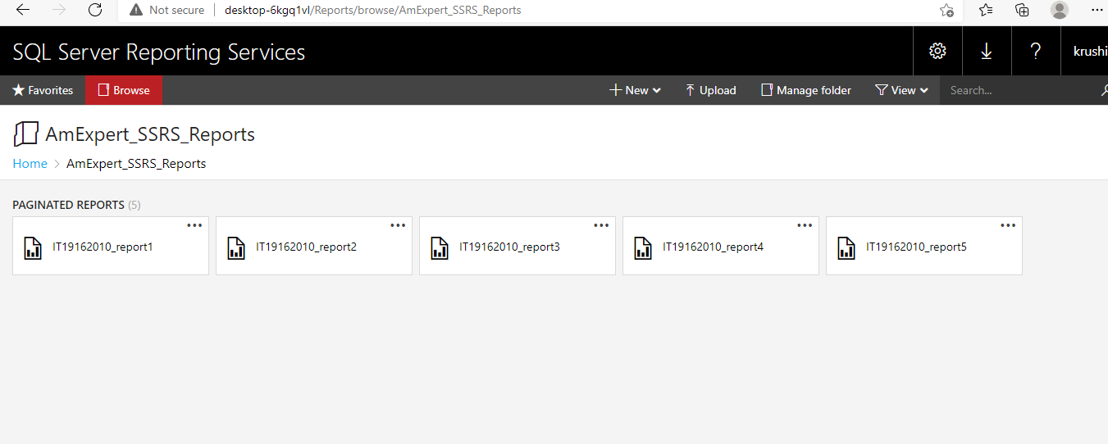Next the SSRS project was created by giving the server’s name and SSAS in Report Builder.

Report 1- Report with matrix (IT19162010_report1)

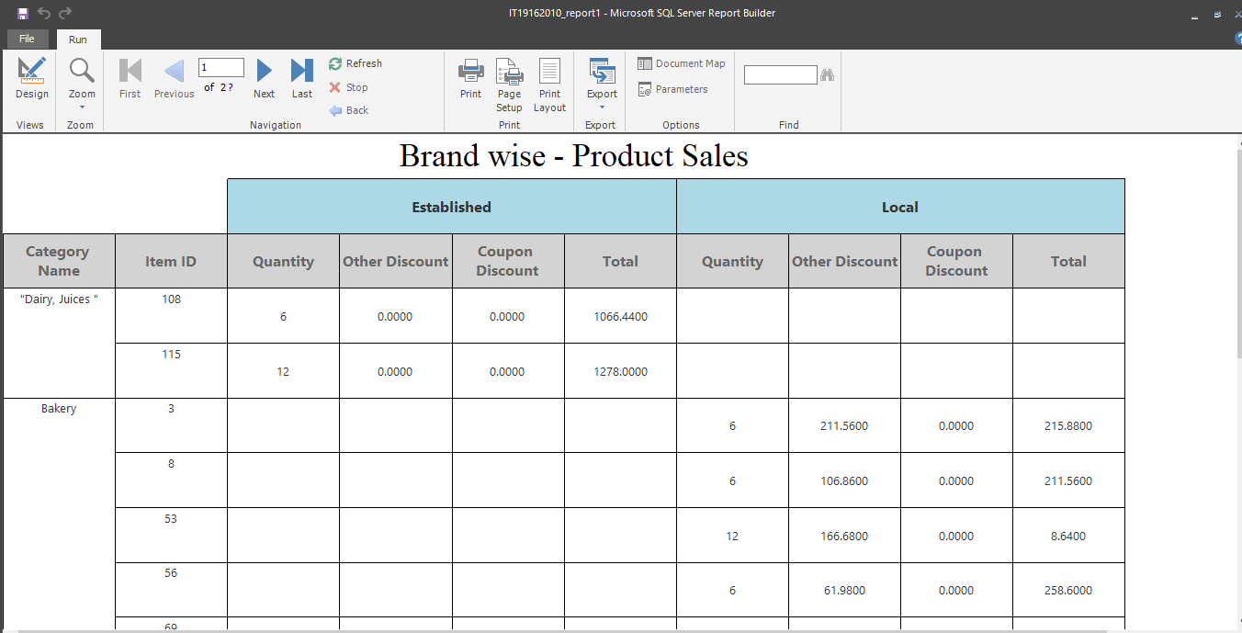The Brand Wise product sales analysis report reflects product sales monitored on a Brand basis. Total income, coupon discount, other discount and quantity reflected Item brand wise.

Report 2- Report with more than one parameter(IT19162010_report2)

The product category sales – Brand wise analysis report has more than 1 parameter. They are, Category name and Item ID. Both the parameters contain listed values and user can select multiple values from the list. product sales monitored on a monthly basis. Total income, coupon discount, other discount and quantity reflected Item brand wise. And also, there are some visualizations such as bar chart, pie chart and line chart for the observations.

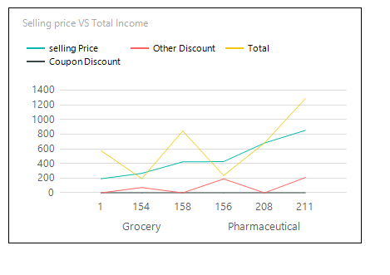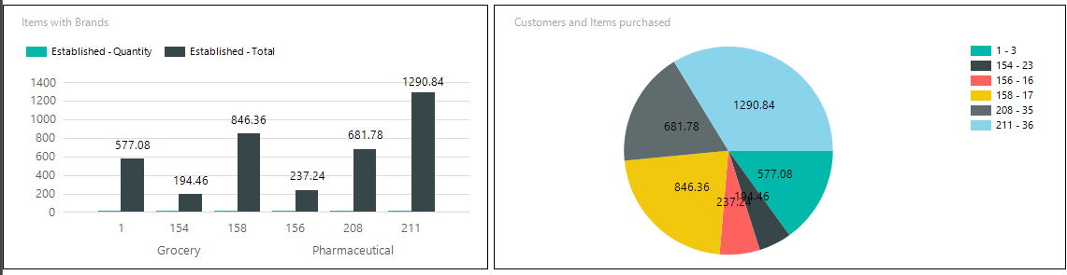

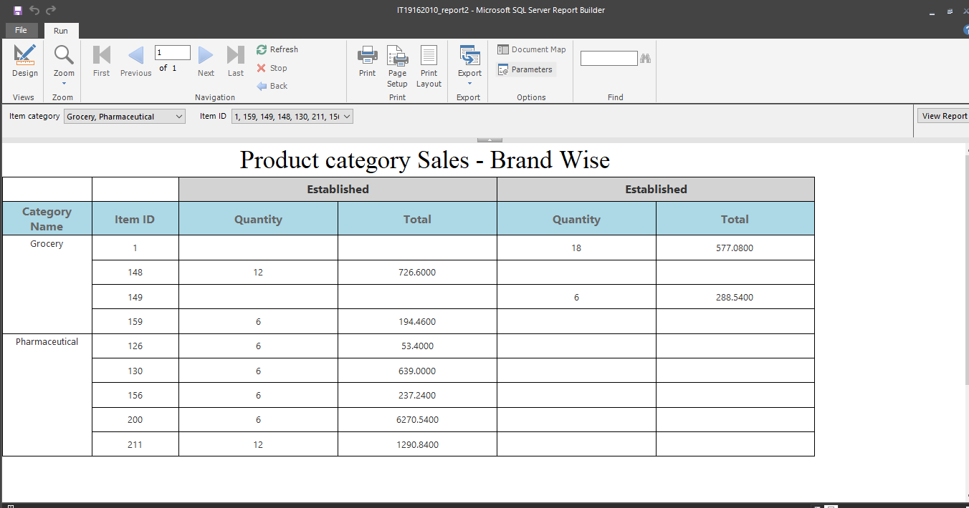

Report 3- SSRS Drill – Down Report (IT19162010_report5)

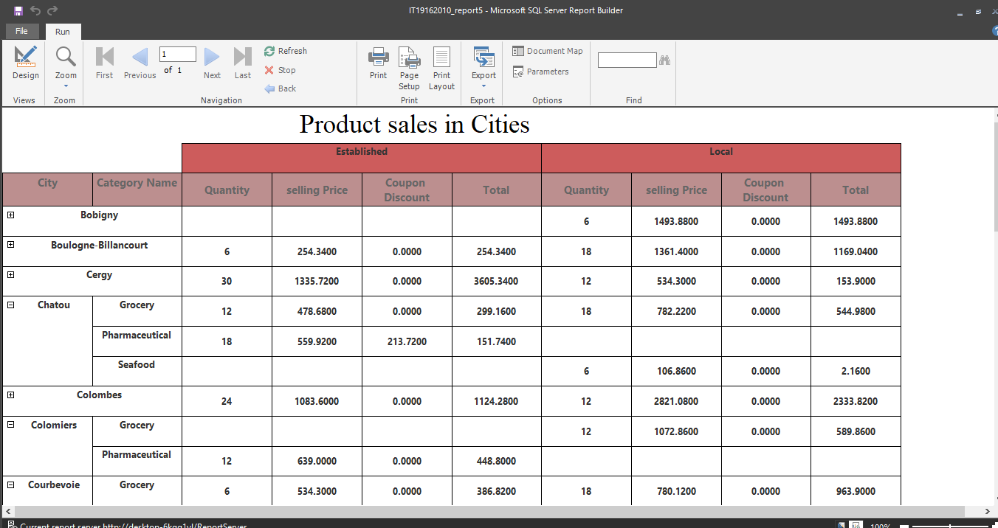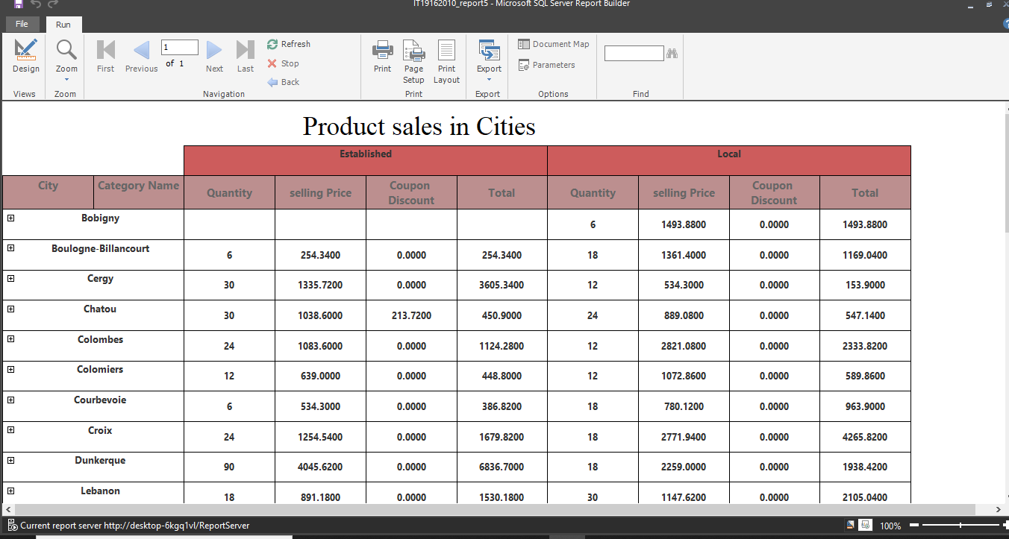The product category sales in cities analysis are a report with a SSRS drill down. Details of the report can be drilled down to categories for each city. This report helps to have an idea about the discounts and payments after deduction of discounted amounts analyzed on a locational manner.

Report 3- SSRS Drill – Through Report (IT19162010_report3, IT19162010_report4)

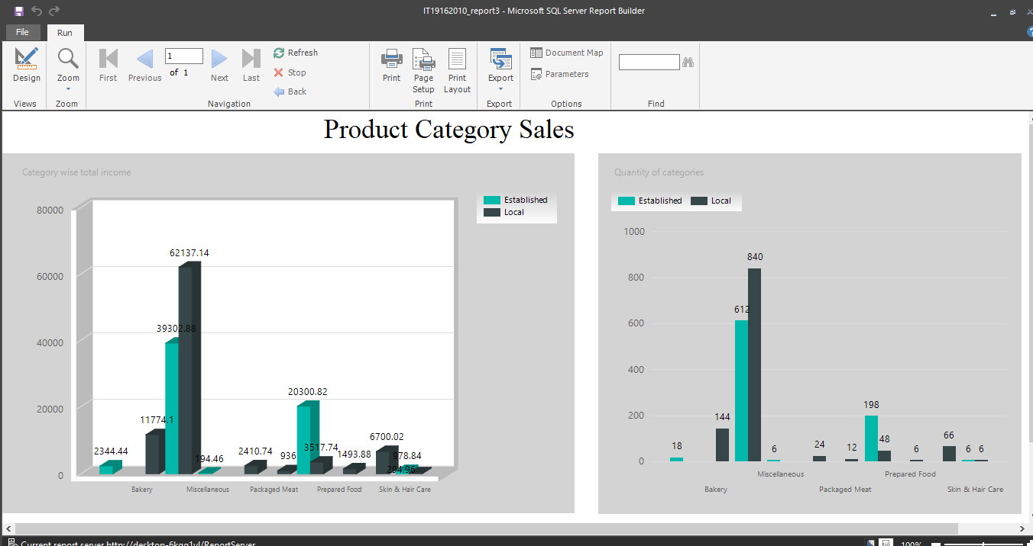IT19162010_report3 is report with SSRS drill-through. It reflects Item categories VS Total costs and Categories VS Quantities. The purpose of this task is to create a second level report. In order to do this, report3 allows user to click on categories which is in charts. When clicked on a category, the user needs to be taken to a (second level) product sales-customer based report, where the total income of categories shown in the report are customers and their age range that belong to the selected category in the first level report. Which means, by selecting particular category from first level report, we can view the customer ID and their age range of the customers who have bought that particular category items.

